Unit 1 review

**Multiple Choice Questions**

1. A random sample of 25 birthweights (in ounces) is taken yielding the following summary statistics:



|  |  |  |  |  |  |  |
| --- | --- | --- | --- | --- | --- | --- |
| Variable | N | Mean | Median | TrMean | StDev | SE Mean |
| Birthwt | 25 | 129.40 | 129.00 | 128.35 | 17.41 | 3.48 |
| Variable | Minimum | Maximum | Q1 | Q3 |  |  |
| Birthwt | 96.00 | 187.00 | 119.50 | 135.50 |  |  |

What can be said about the number of outliers for this data set?



1. 0



1. At least 1

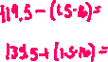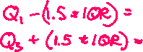

1. No more than 1



1. At least 2



1. No more than 2



1. For a set of values, suppose the mean is 10 and the standard deviation is 2. If each value is multiplied by 9 and added by 10, what will be the mean and standard deviation for this new set of values?



1. mean 10; standard deviation 2



1. mean 10; standard deviation 18



1. mean 100; standard deviation 2
2. mean 100; standard deviation 18



1. mean 100; standard deviation 28
2. In this year’s county mathematics competition, a student scored 40; in last year’s competition, the student scored 35. The average score this year was 38 with a standard deviation of 2. Last year’s average score was 34 with a standard deviation of 1. In which year did the student score better?



1. The student scored better on this year’s exam



1. The student scored better on last year’s exam



1. The student scored equally well on both exams



1. Without knowing the number of test items, it is impossible to determine the better score.
2. Without knowing the number of students taking the exam in the county, it is impossible to determine the better score.



1. The heights of American men aged 18 to 24 are approximately normal with a mean of 68 inches and a standard deviation of 2.5 inches. About 20% of these men are taller than



1. 66 inches
2. 68 inches
3. 70 inches



1. 72 inches
2. 74 inches

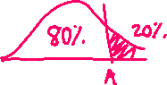

1. The lengths (in innings) of 25 randomly selected Little League baseball games were recorded, and a *cumulative* frequency histogram was created from the results. What is the best conclusion that can be made from the graph?



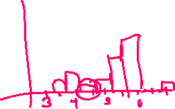

1. The median game length is 5 innings



1. Fourteen games lasted 5.5 innings



1. A majority of the games lasted 6 or more innings
2. The distribution of game lengths is severely skewed left



1. Games lasting more than 6 innings occurred least frequently
2. Which statement is true about the boxplot below?





1. It is a left skewed distribution which has outliers



1. It is a symmetrical distribution which has outliers



1. The interquartile range is less than 1



1. Approximately 75% of the observations have a GPA less than 3



1. I only
2. II only
3. II and III
4. III and IV only
5. I, III, and IV



1. The scores of a standardized test designed to measure math anxiety are normally distributed with a mean of 100 and a standard deviation of 10 for a population of first year college students. Which of the following observations would you suspect is an outlier?



1. 90



1. 100
2. 150



1. 90, 100, and 150 are all outliers

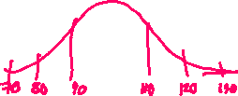

1. None of 90, 100, and 150 are outliers
2. Which of the following distributions has a mean of 30 and a standard deviation of 7?
3. (B)







1. (D)



 (E)





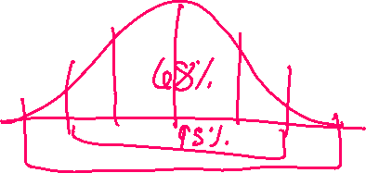

1. A researcher interested in the age at which women are having their first child surveyed a simple random sample of 250 women having at least one child and found a approximately normal distribution with a mean age of 27.3 and a standard deviation of 5.4. Approximately 95% of the women had their first child between the ages of



1. 11.1 years and 43.5 years

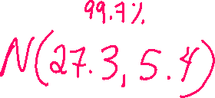

1. 16.5 years and 38.1 years



1. 21.9 years and 32.7 years
2. 21.9 years and 38.1 years
3. 25.0 years and 29.6 years



Use the following for questions 10 and 11.



1. Which distribution above has the smallest standard deviation?
2. A
3. B



1. C
2. It cannot be determined from the graphs
3. All three distributions have the same standard deviation
4. In which distribution(s) would you be more likely to find the mean and median the same?
5. A only
6. B only
7. C only
8. A and B only
9. A, B, and C



1. A study was done to determine if the method of instruction (either lecture or discussion) depended on the type of class which was being taught. Twenty art classes, seventeen math classes and twenty-five science classes were observed. The method of instruction, discussion or lecture, was recorded. Which of the following best describes the relationship between method of teaching and type of class?



|  |  |  |
| --- | --- | --- |
|  | Discuss | Lecture |
| Arts | 5 | 15 |
| Math | 12 | 5 |
| Science | 15 | 10 |

1. There appears to be no relationship since the number of discussion class and the number of lecture classes was exactly the same
2. No association can be determined since the number of art, math, and science classes were not exactly the same



1. There appears to be an association since the art class was less likely to use discussion than either math or science
2. There appears to be an association since the number of math and science classes is greater than the number of arts classes



1. A measure of association cannot be determined from these data



1. Polly takes three standardized tests. She scores 600 on all three. Using standard scores, or z-scores, rank her performance on the three tests from best to worst if the means and standard deviations for the tests are as follows:



|  |  |  |
| --- | --- | --- |
|  | Mean | Standard Deviation |
| Test I | 500 | 80 |
| Test II | 470 | 120 |
| Test III | 560 | 30 |



1. I, II, and III
2. III, II, and I
3. I, III, and II
4. III, I, and II

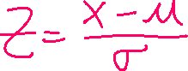

1. II, I, and III
2. Which of the following will most likely approximate a uniform distribution?
3. Heights of students at a particular high school
4. Weights of students at a particular high school
5. SAT scores of seniors at a particular high school
6. IQ scores of students at a particular high school
7. Ages of students at a particular high school



1. Which of the following is more likely to be true of this distribution?

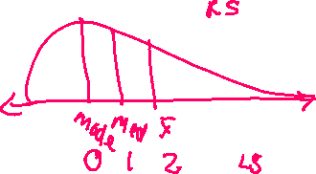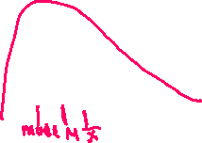

1. Mean = 3 Median = 3 Mode = 3



1. Mean = 3.5 Median = 4 Mode = 3



1. Mean = 4 Median = 3.5 Mode = 3
2. Mean = 3.5 Median = 3.5 Mode = 5



1. Mean = 3 Median = 2 Mode = 5

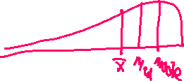

1. If the standard deviation of a distribution is 4, the variance is:



1. 4



1. 2



1. 8
2. 16



1. 0



1. The distribution of pregnancy length (in days) from conception to birth for humans follows a normal model with a mean of 266 days and a standard deviation of 16 days.
2. Sketch and label the normal model



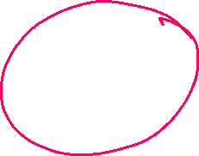

1. Find the length of the longest 16% of all pregnancies.



1. Find the length of the middle 99.7% of all pregnancies.



1. Find the length of the shortest 2.5% of all pregnancies.

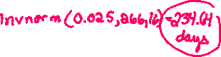

1. What z-score does a pregnancy of 257 days have?



1. What percent of humans have a pregnancy lasting less than 257 days?



1. What percent of humans have a pregnancy lasting longer than 280 days?



1. What percent of humans have a pregnancy lasting between 260 and 270 days?



1. How long would a pregnancy have to last to be in the longest 10% of all pregnancies?



1. How short would a pregnancy be to be in the shortest 25% of all pregnancies?



1. The life expectancy of a particular brand of light bulb is normally distributed with a mean of 1500 hours and a standard deviation of 75 hours.
2. What is the probability that a light bulb will last less than 1350 hours?
3. What is the probability that a light bulb will last more than 1700 hours?
4. What is the probability that a light bulb will last between 1600 and 1780 hours?
5. 22% of the time a light bulb will last more than how many hours?